**HDFS Assignment**

1. **Create a new HDFS file structure data/dev/analysis in the HDFS home directory. Copy the covid-19 folder into it.**

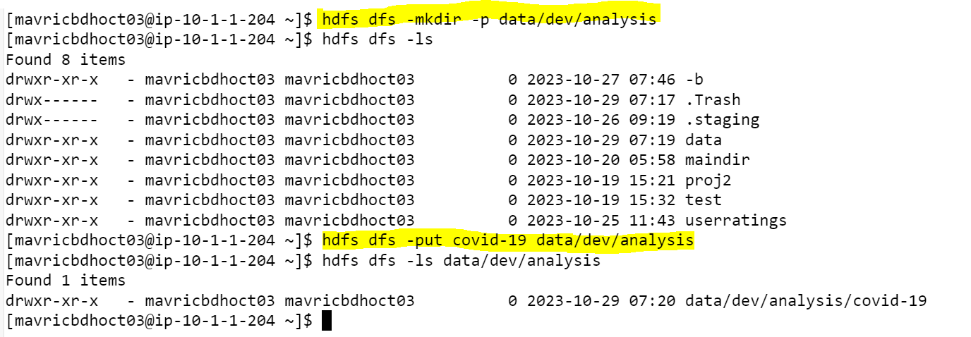

1. **Change the permission of Covid_patient_Apr26.csv file to have only read/write/execute for the owner/ group and read/write permission for others.**

1. **Copy covid-19 folder in to another hdfs directory data/prod/analysis**

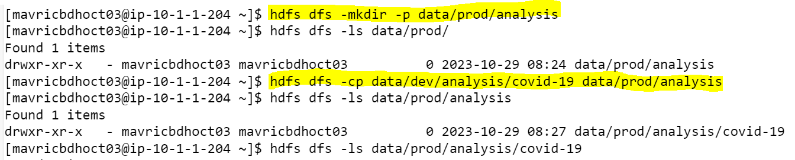

1. **Read the contents of the file Covid_patient_Apr19.csv and print the contents on the screen.**

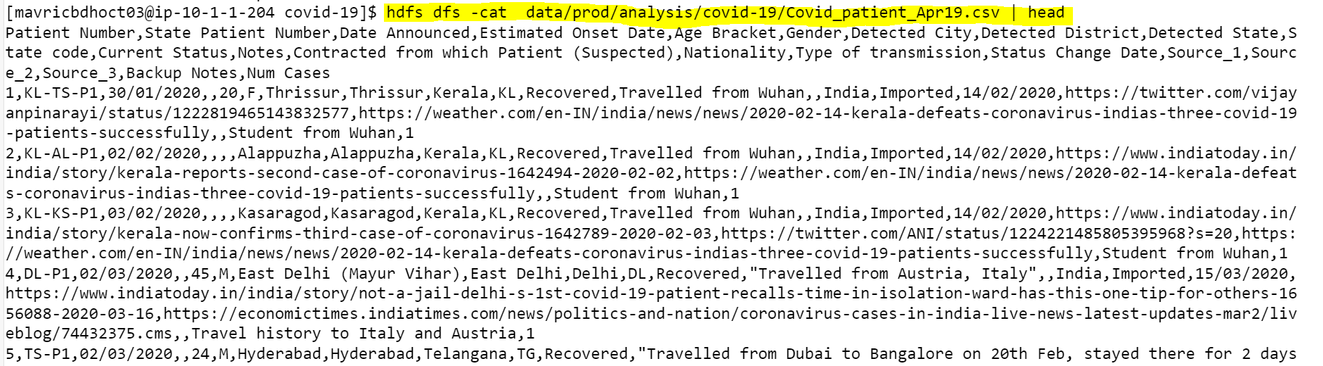

1. **Print the no of lines present in the HDFS file Covid_patient_Apr19.csv**



1. **Count the no of records present in the HDFS file Covid_patient_Apr19.csv for the state “UP”**



1. **Delete the file Covid_patient_Apr19.csv from the data/prod/analysis folder in HDFS.**

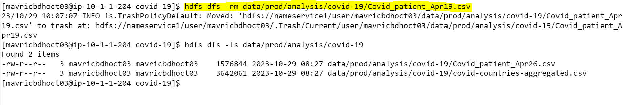

1. **Delete the covid-19 folder from both the dev and prod folders created above.**



1. **Copy the tickitdb folder(in the local file system) in to HDFS home directory. How many blocks will be created for the files in this directory?**

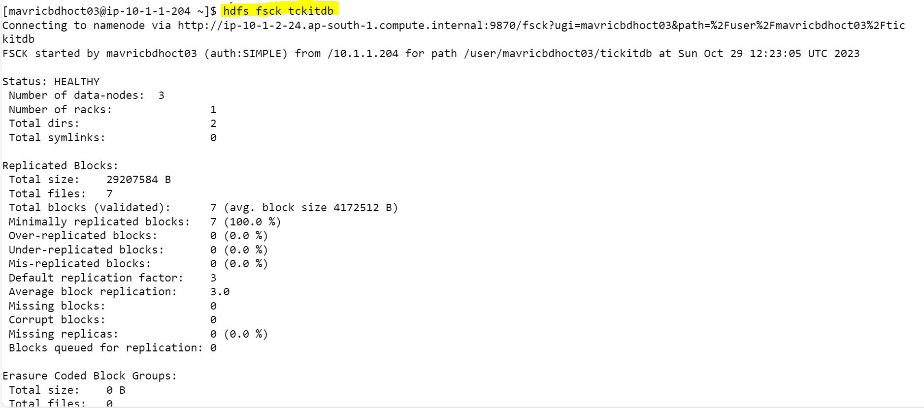

1. **Find all the file names which has the word “pipe” in their names.**

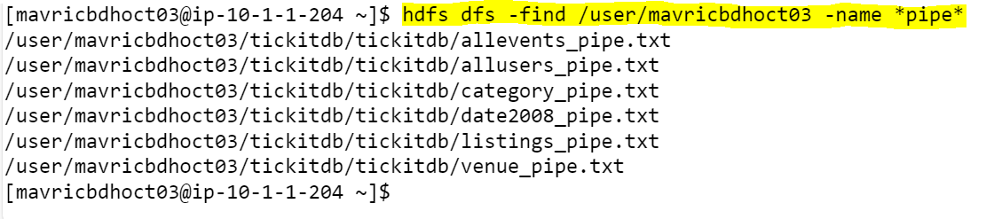

1. **Copy the h1b.csv file to hdfs home directory. How many blocks will be created for this file?**

1. **Move the h1b.csv file (in the HDFS) to the tickitdb folder in hdfs. How many blocks will be there for the tickitdb folder?**

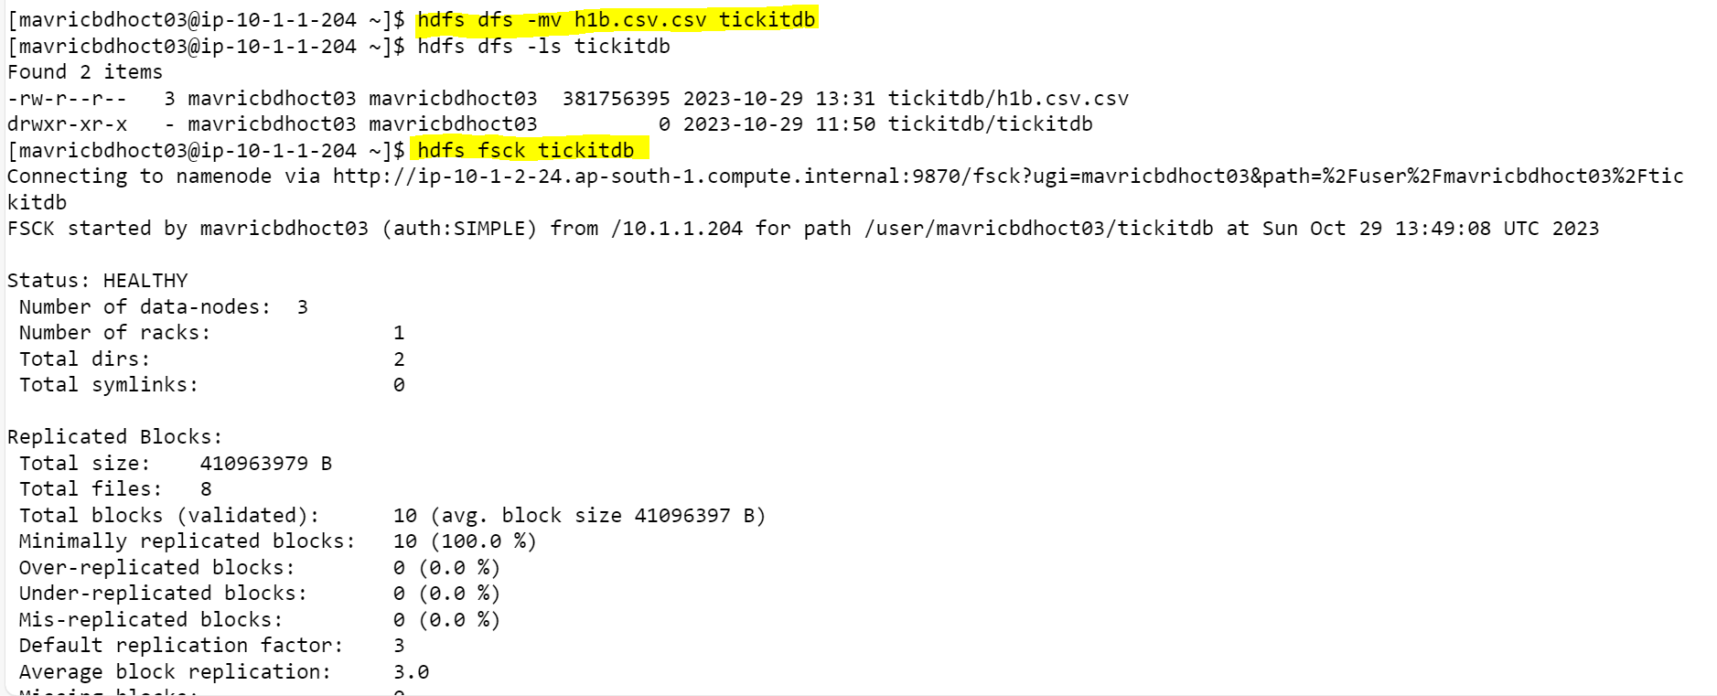

1. **Calculate the total storage space occupied by the files directory and its contents.**

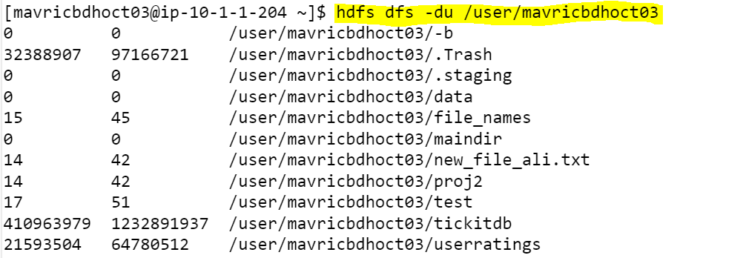

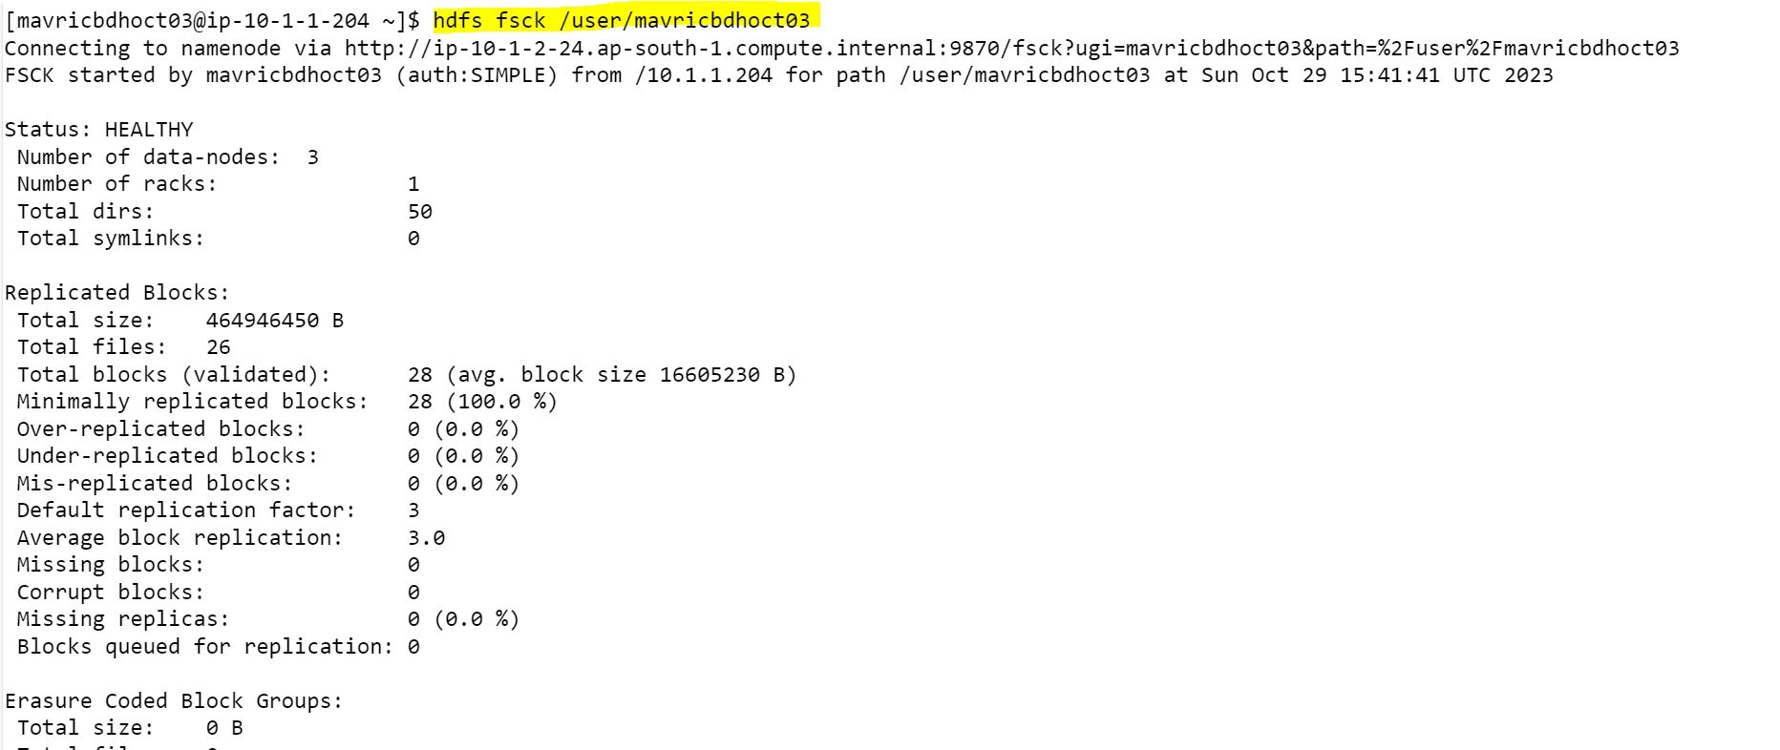

1. **Check the storage quota for the file directory.**



1. **Delete a specific snapshot ‘snapshot1’ from the file directory.**

**Note: Don’t have access just pasted the code for reference**





1. **Create a snapshot of the file directory in HDFS.**

**Note: Don’t have access just pasted the code for reference**





1. **Set a replication factor of 3 for all files within the file directory**.

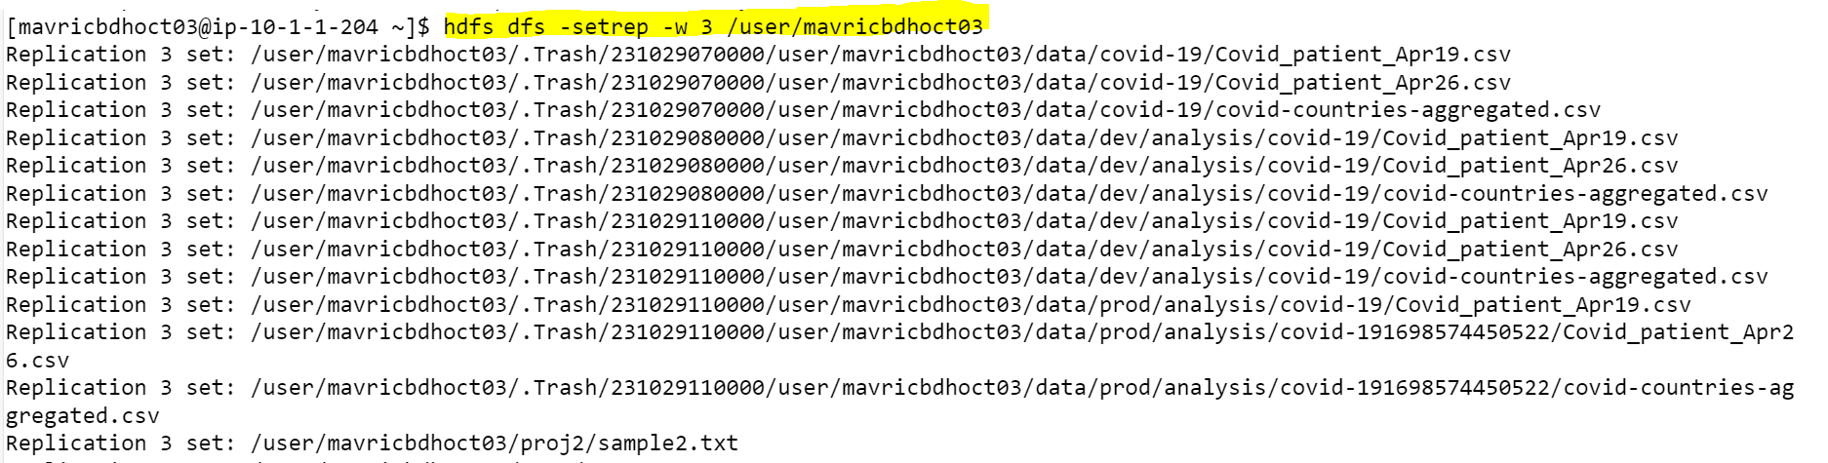

1. **Rename the 'file name' file to 'new file name' within the file directory in HDFS.**

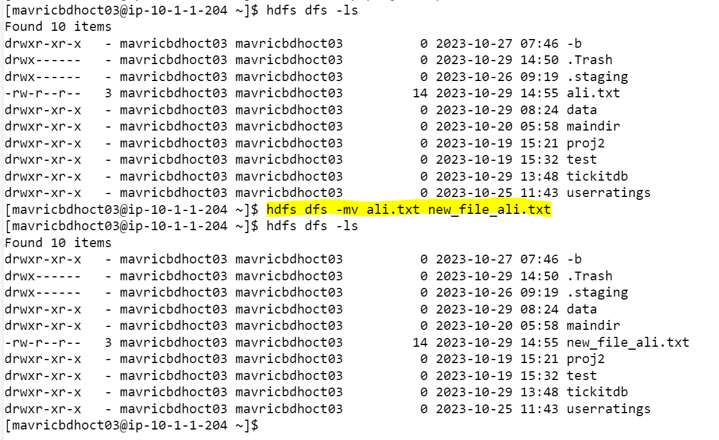

1. **List all the files and directories in the files directory in HDFS**

1. **Create an HDFS directory file names in your home directory and upload a local file 'test.txt' to it.**



